**525/2**

**CHEMISTRY**

**PAPER 3**

**JULY/AUG 2024**

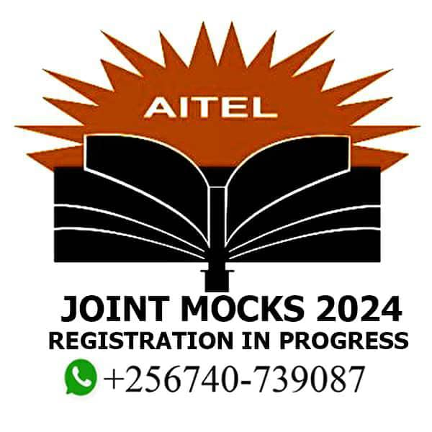

**ASK INTEGRATED TEACHERS MOCK EXAMINATIONS BURREAU**

**AITEL JOINT MOCK EXAMINATIONS.**

**Uganda Advanced Certificate of Education**

CHEMISTRY PRACTICALS INSTRUCTIONS.

**525/3 Inst. Sch.**

***CONFIDENTIALS***

**This instruction is given only to facilitate preparation of examinations.**

Great care should be taken that the information given below does not reach the candidates either directly or indirectly.

**INSTRUCTIONS FOR PREPARING APPARATUS**

The head teacher must ensure that the teacher responsible for preparing the chemicals and apparatus hands in his/her trail results properly sealed in a separate envelope and firmly fastened (attached) to the candidates’ scripts envelop(s).

1. The description of the reagents and chemicals specified below does not necessarily correspond with the description in the question paper. Candidates must not be informed of the differences.
2. Candidates are not allowed to use reference books (i.e. text books, booklets on qualitative analysis etc.) during examination.
3. In addition to the fittings and substances ordinarily contained in a chemistry laboratory, each candidate will require: In addition to the apparatus ordinarily contained in a physics laboratory, each candidate will require;
4. FA1 0.05M ${Na}_{2}S_{2}O_{3}. 5H_{2}O$. 12 ${20Cm}^{3}$ each
5. FA2 6% (20v) OF hydrogen peroxide 25 ${cm}^{3}$ each
6. T is solid potassium manganite (VII) 1g each
7. 1M sulphuric acid 160 ${cm}^{3}$ each
8. 5% potassium Iodide solution 60 ${cm}^{3}$ each
9. G is a mixture of magnesium Iodide and lead(II) nitrate in the ratio of 1:3
10. R is butanone (methyl ethyl ketone)
11. Apparatus
12. Measuring cylinder (100/50 ${cm}^{3}$)
13. Beaker (50 ${cm}^{3})$
14. 250 ${cm}^{3}$ volumetric flask
15. Burette (50 ${cm}^{3})$
16. Pipette (10 ${cm}^{3})$
17. 6 test tubes

**This information MUST be completed and returned in a separate envelope firmly attached to the script envelope(s).**

**REPORT ON CHEMISTRY PRACTICAL 525/3**

**Section I:**

Any information which the teacher responsible for preparing the apparatus thinks may be useful to the examiners should be given on this sheet. The teacher must try the items and submit his/her results in the space provided below to guide the examiners about the apparatus and concentrations of the chemicals used.

**NB:** Teachers who DO NOT submit their trial results will be held responsible for their candidates’ performance.

**Results:**

**________________________________________________________________________________________________________________________________________________________________________________________________________________________________________________________________________________________________________________________________________________________________________________________________________________________________________________________________________________________________________________________________________________________________________________________________________________________________________________________________________________________________________________________________________________________________________________________________________________________________________________________________________________________________________________________________________________________________________________________________________________________________________________________________________________________________________________________________________________________________________________________________________________________________________________________________________________________________________________________________________________________________________________________________________________________________________________________________________________________________________________________________________________________________________________________________________________________________________________________________________________________________________________________________________________________________________________________________________________________________________________________________________________________________________________________________________________**

**Section II:**

The Invigilator in consultation with the teacher responsible for preparing the apparatus should give details below of any difficulties experienced by particular candidates, giving their names and personal numbers. This should include reference to:

(a) Difficulties due to faulty apparatus

_______________________________________________________________________________________________________________________________________________________________________________________________________________________

(b) Accidents due to apparatus or materials,

________________________________________________________________________________________________________________________________________________________________________________________________________________________

(c) Physical handicaps of candidates,

________________________________________________________________________________________________________________________________________________________________________________________________________________________

(d) Any other information.

________________________________________________________________________________________________________________________________________________________________________________________________________________________

Other cases of hardship e.g. illness, disability, should be reported directly to **AITEL** in the normal way.

A plan of work benches, giving details by personal numbers of the places occupied by the candidates for each session, must be enclosed with the scripts.

DO NOT STAMP ANYWHERE ON THIS DOCUMENT.

Invigilator’s Name: ___________________________________Signature____________

Signature of the teacher responsible for preparing chemicals: ______________________

Signature of the head teacher: _______________________________________________

***END***